**WCAG Findings**

The current WCAG (Web Content Accessibility Guidelines) changes will be affecting in all

**ABS (Authentication Based Signing)** Embedded signing process. Since these findings has been reported for some of the pages.

There are changes in HTML structure in few pages which is as below.

**Change 1:**

|  |
| --- |
| **Technical**:  We have removed tabindex attribute which was not allowing tab key to navigate through the page. After removal of tabindex from Signing page, it is allowed to navigate in proper navigation through the page.  The following html structure has update on removing tabindex in document view/listing page.          The following html structure has update on removing tabindex in index page. |

Probably this HTML structure change doesn’t require in any custom CSS changes but still needs a check whether custom CSS has any specific to tabindex.

**Single Document Signing**

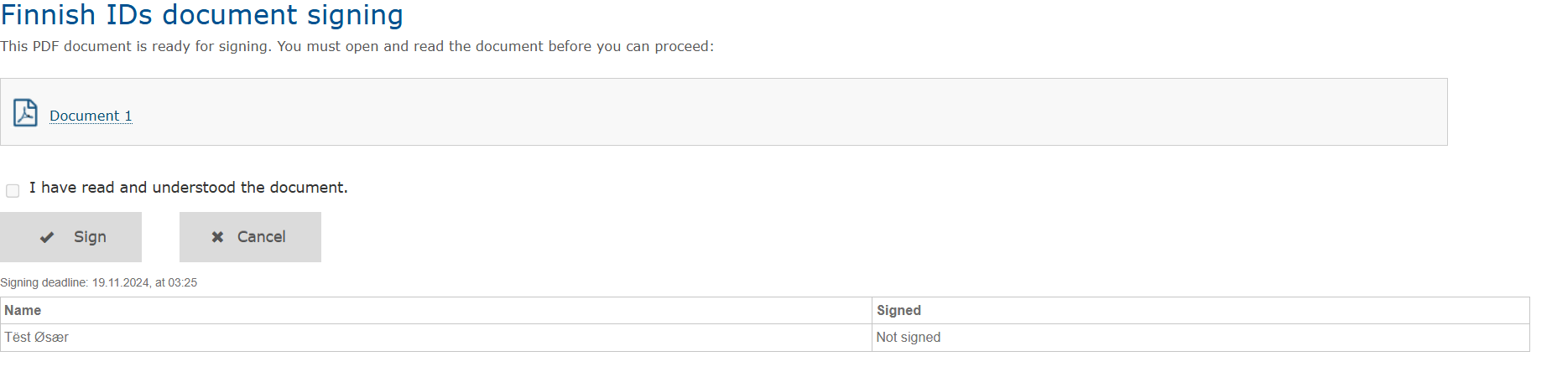

The same applies for **Multi Document Signing** as below.

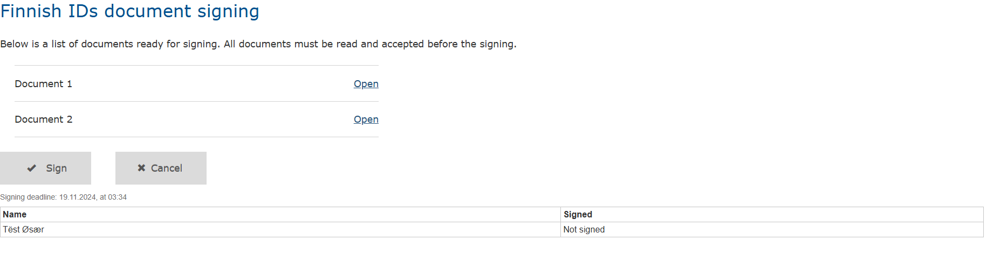

Opening one of the documents from document list, Application navigates to the below page where tab key has been handled here too.

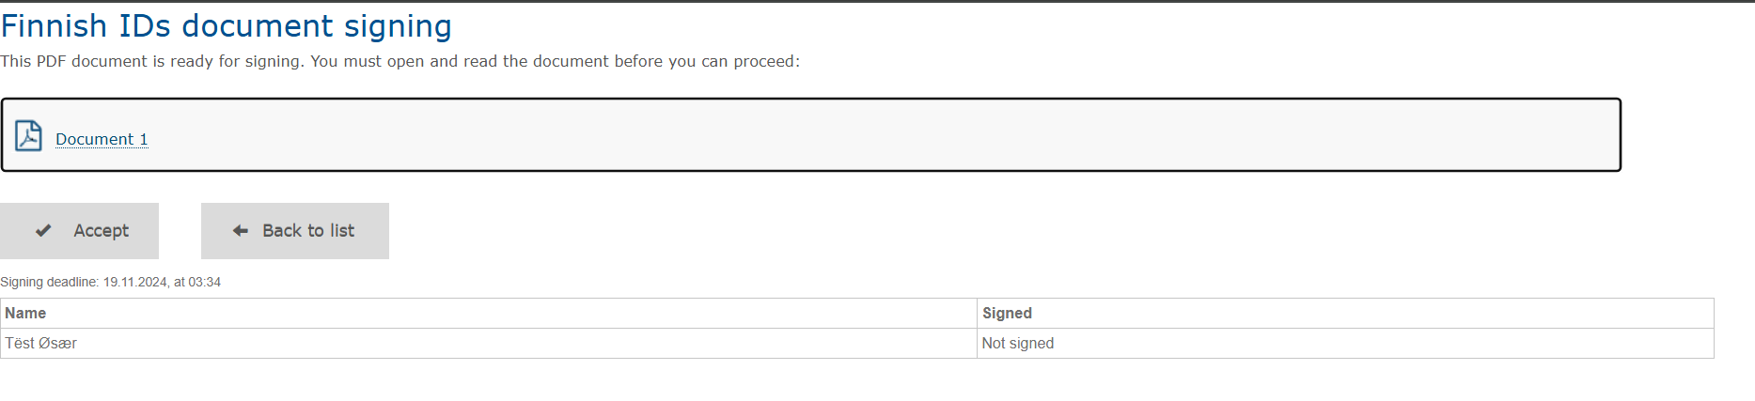

**Change 2:**

Update in checkbox, consent message field in HTML structure in Document signing page.

**Technical:**

|  |
| --- |
| **Previous Implementation:**  HTML page has agreement label inside the checkbox input element which showed checkbox as dimmed.    **Current updated implementation:**  HTML page has checkbox element inside the agreement label which shows agreement text as expected and by clicking agreement text, checkbox gets checked. |

Document consent page is not as expected in some of the custom CSS after the update of Checkbox and consent field update in HTML structure, some HTML elements are missing after update few are listed below and there might be other CSS too.

There might be an update in custom CSS according to current HTML structure change.

**Change 3:**

Screen reader reads text into pieces, this has been fixed by removing inline span which is in document signing page.

**Technical**

|  |
| --- |
| Removed inline span and made the whole text into single span which helps screen reader to read the whole sentence.  Current Structure:      Updated Structure: |

The highlighted text below pages for PDF and TEXT document type comes under single span in document list page.

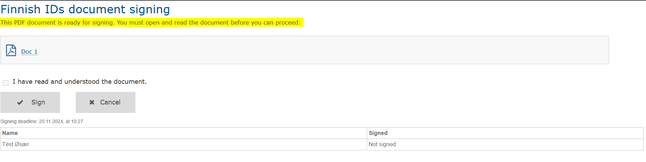

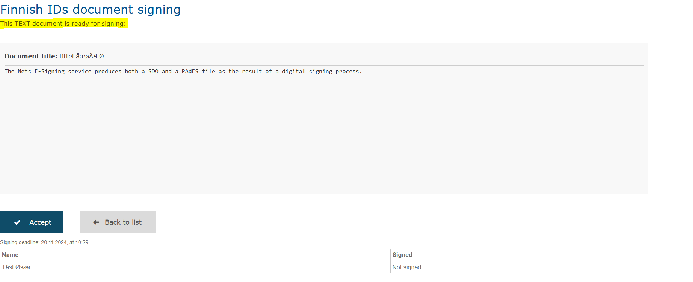

**Change 4:**

External links for Documents and Attachments are not marked correctly.

Screen reader doesn’t say that the links open in new window/tab and external link icon is missing.

"opens in new window" icon will be shown besides the link if it opens in external window/tab through CSS style to apply graphics icon.